1. Capture and analyze ARP packets using Wireshark. Inspect the ARP request and reply frames, and discuss the role of the sender's IP and MAC address in these packets.
- Open terminal and start Wireshark:
sudo wireshark
- Select the active network interface:
eth0 or wlan0
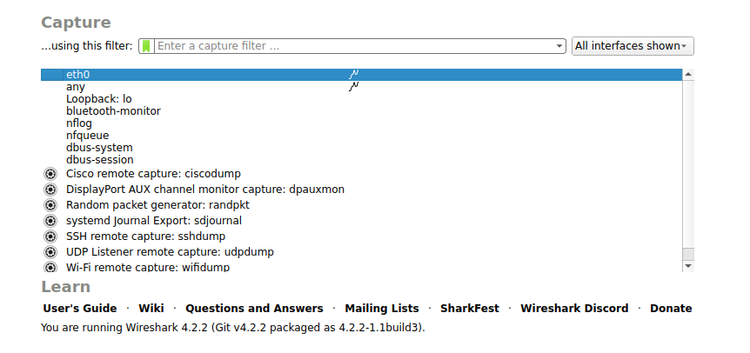

- Click on Start Capture (Shark fin icon)
- Open a new terminal window.
- Generate traffic using:
ping 8.8.8.8
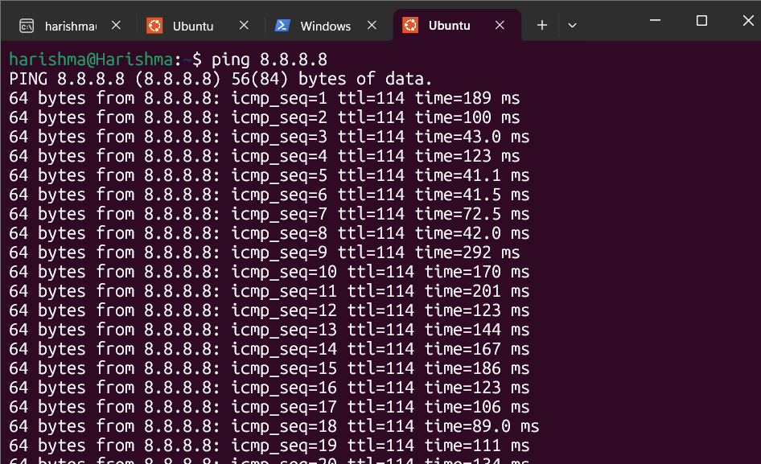
- Go to Wireshark and apply filter:
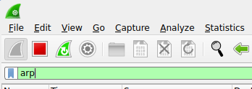
- Observe ARP request and reply packets.
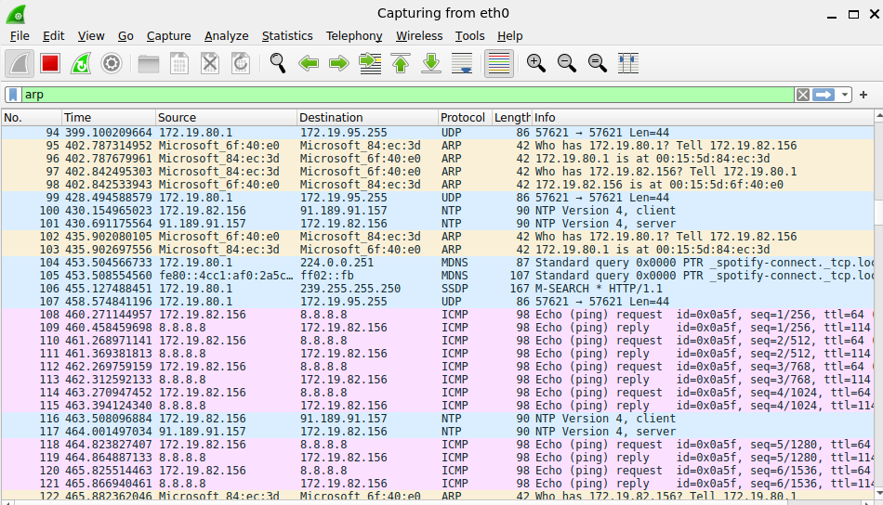
- Stop the capture after few seconds.
2. Using Packet Tracer, simulate an ARP spoofing attack. Analyze the behavior of devices on the network when they receive a malicious ARP response.
- Open Cisco Packet Tracer.
- Place one switch and three PCs on the workspace.
- Connect all PCs to the switch using copper straight-through cables.
- Assign IP addresses to the PCs:
  - PC1: 10.10.10.1
  - PC2: 10.10.10.2
  - PC3: 10.10.10.3
  - Subnet Mask: 255.255.255.0
  - Default Gateway: 10.10.10.3
- On PC1, open Command Prompt and verify connectivity:
ping 10.10.10.3
- Check the ARP table:
arp -a

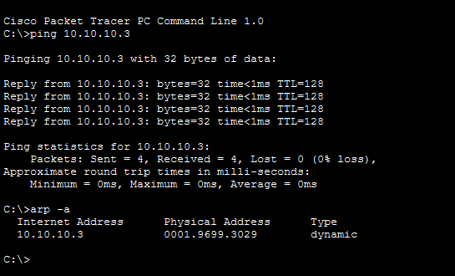

- Switch to Simulation Mode in Packet Tracer.
- Click on “Edit Filters” and select only ARP protocol.
- Clear the ARP cache on PC1:
arp -d
- Generate ARP traffic again by:
ping 10.10.10.3
- Click “Capture/Forward” to observe ARP packets.
- Analyze ARP request and ARP reply packets in the simulation.
- Note that in ARP spoofing, an attacker can send fake ARP replies to mislead the victim system.
3.Manually configure static IPs on the client devices (like PC or your mobile phone) and verify connectivity using ping
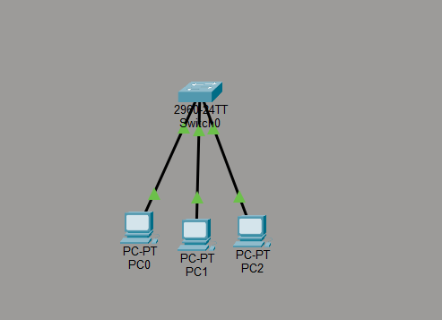
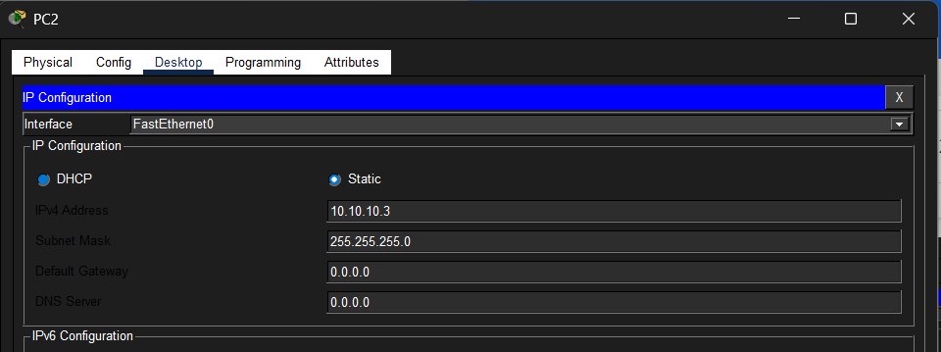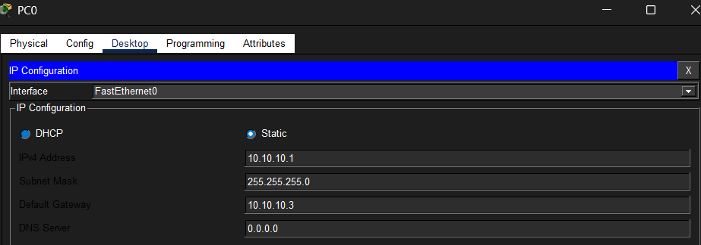
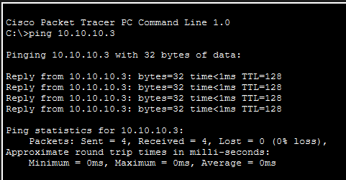
Static IP addresses were manually configured on the PCs using Cisco Packet Tracer. Each PC was assigned an IP address in the same network along with the appropriate subnet mask. After configuration, connectivity was verified by sending a ping from PC1 to PC3. The ping was successful, indicating that the devices were correctly configured and able to communicate with each other over the network. This demonstrates that static IP addressing enables proper communication when all devices are in the same subnet.

4. Use Wireshark to capture DHCP Discover, Offer, Request, and Acknowledge messages and explain the process.
- Open Wireshark.
- Select the active network interface (Wi-Fi or Ethernet).
- Start packet capture by clicking the shark fin icon.
- Apply the filter:
bootp
- Disconnect and reconnect the network (Wi-Fi or Ethernet) to generate DHCP traffic.
- Observe the captured packets in Wireshark.
- Identify the DHCP messages:
  - DHCP Discover
  - DHCP Offer
  - DHCP Request
  - DHCP Acknowledge
- Click on each packet to view detailed information such as IP address, MAC address, and transaction ID.
- Stop the capture after observing the required packets.

🔍 Explanation of DHCP Process (DORA)

🔹 DHCP Discover
- Sent by the client to locate available DHCP servers.
- It is a broadcast message.

🔹 DHCP Offer
- Sent by the DHCP server in response to the Discover message.
- It offers an IP address and network configuration to the client.

🔹 DHCP Request
- Sent by the client to request the offered IP address.
- It confirms the selection of a particular DHCP server

🔹 DHCP Acknowledge (ACK)
- Sent by the server to confirm the allocation of the IP address.
- The client can now use the assigned IP address.
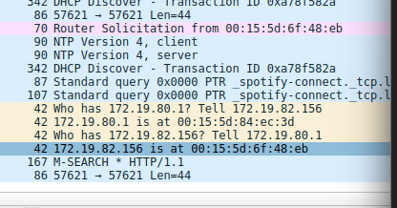
5.Given an IP address range of 192.168.1.0/24, divide the network into 4 subnets.
Task: Manually calculate the new subnet mask and the range of valid IP addresses for each subnet.
Assign IP addresses from these subnets to devices in Cisco Packet Tracer and verify connectivity using ping between them.

Given Network
- IP: 192.168.1.0/24
- Need: 4 subnets

Subnet Calculation
To create 4 subnets:
- (2^2 = 4) → borrow 2 bits
- New subnet mask = /26
New Subnet Mask:
- Decimal: 255.255.255.192

Subnet Ranges
Subnet | Network Address | Valid IP Range | Broadcast
1 | 192.168.1.0 | 192.168.1.1 – 192.168.1.62 | 192.168.1.63
2 | 192.168.1.64 | 192.168.1.65 – 192.168.1.126 | 192.168.1.127
3 | 192.168.1.128 | 192.168.1.129 – 192.168.1.190 | 192.168.1.191
4 | 192.168.1.192 | 192.168.1.193 – 192.168.1.254 | 192.168.1.255

Packet Tracer
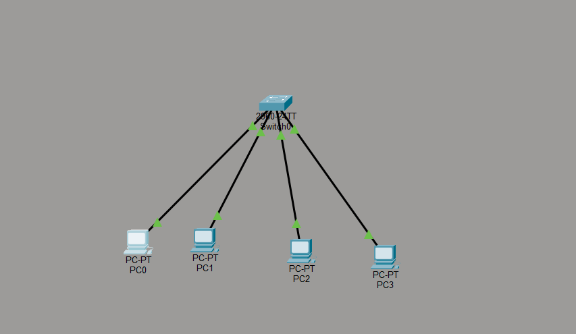

Example:
- PC1 → 192.168.1.1
- PC1 → 192.168.1.2
- PC2 → 192.168.1.65
- PC3 → 192.168.1.66

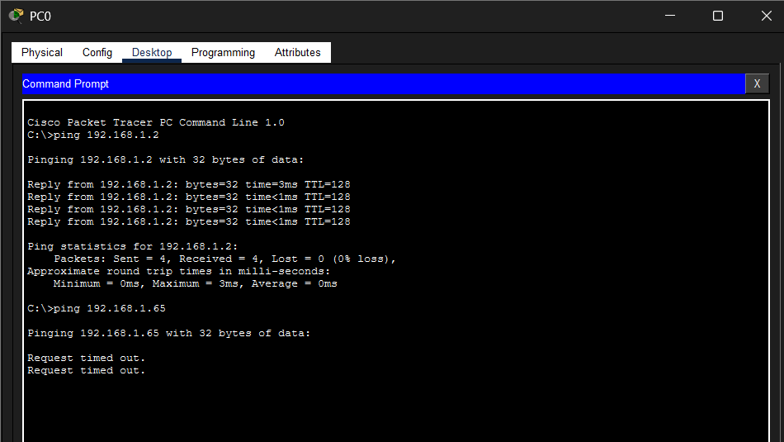
• Different subnets cannot communicate without router
• Switch only works within same subnet
“Given the network 192.168.1.0/24, it was divided into 4 subnets by borrowing 2 bits, resulting in a new subnet mask of 255.255.255.192 (/26). Each subnet contains 64 IP addresses, including network and broadcast addresses. The valid host ranges for each subnet were calculated accordingly. IP addresses from these subnets were assigned to devices in Cisco Packet Tracer, and connectivity was verified using ping. Successful ping results confirmed proper subnetting and communication between devices.”
6.You are given three IP addresses:
10.1.1.1
172.16.5.10
192.168.1.5
Task: Identify the class of each IP address (Class A, B, or C). What is the default subnet mask for each class?
Provide the range of IP addresses for each class.

IP Address Class Ranges
Class | IP Range | Default Subnet Mask
Class A | 1.0.0.0 – 126.255.255.255 | 255.0.0.0
Class B | 128.0.0.0 – 191.255.255.255 | 255.255.0.0
Class C | 192.0.0.0 – 223.255.255.255 | 255.255.255.0

Classification of Given IP Addresses
IP Address | Class | Default Subnet Mask
10.1.1.1 | Class A | 255.0.0.0
172.16.5.10 | Class B | 255.255.0.0
192.168.1.5 | Class C | 255.255.255.0

7.In Cisco Packet Tracer, create a small network with multiple devices (e.g., 2 PCs and a router). Use private IP addresses (e.g., 192.168.1.x) on the PCs and configure the router to perform NAT to allow the PCs to access the internet.
Task: Test the NAT configuration by pinging an external IP address from the PCs and capture the traffic using Wireshark.
What is the source IP address before and after NAT?
NAT (Network Address Translation):
- Converts private IP → public IP
- Done by router

A network was created using Cisco Packet Tracer consisting of two PCs, a switch, a router, and a server representing the external network. The PCs were connected to the switch, which was further connected to the router. The router was connected to the server to simulate internet access.
The PCs were assigned private IP addresses (192.168.1.1 and 192.168.1.2) with a subnet mask of 255.255.255.0. The default gateway for both PCs was set to 192.168.1.254.

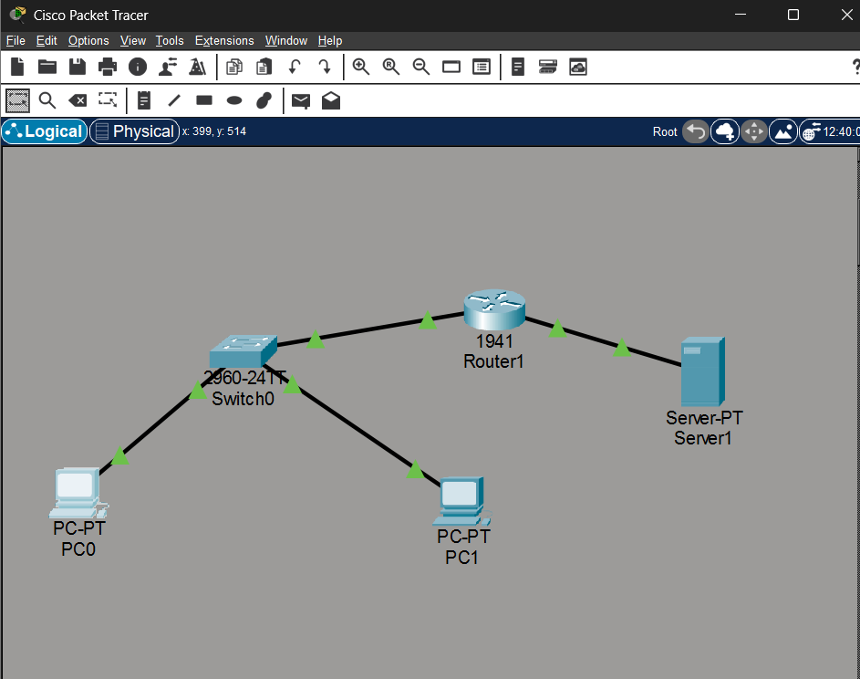

The router was configured with two interfaces: the internal interface (G0/0) with IP address 192.168.1.254 and the external interface (G0/1) with IP address 200.1.1.1.
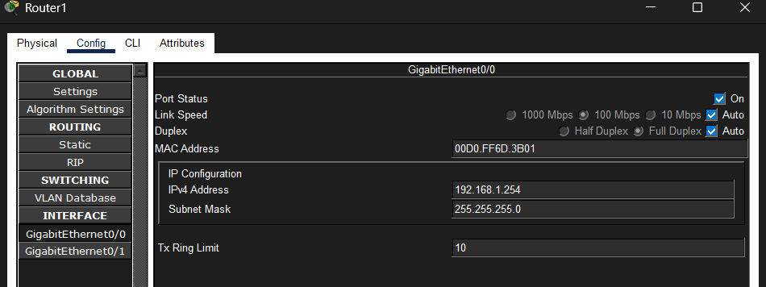

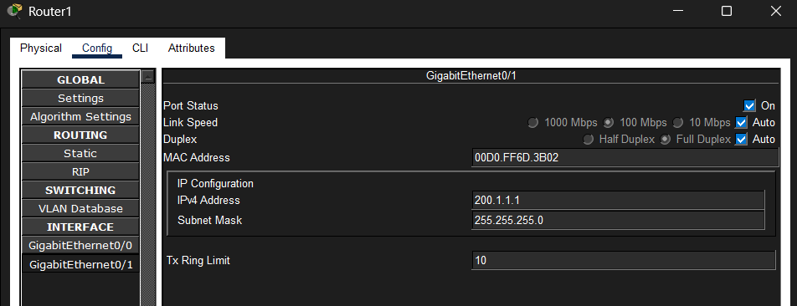

The server was assigned a public IP address 200.1.1.2 with a default gateway of 200.1.1.1.
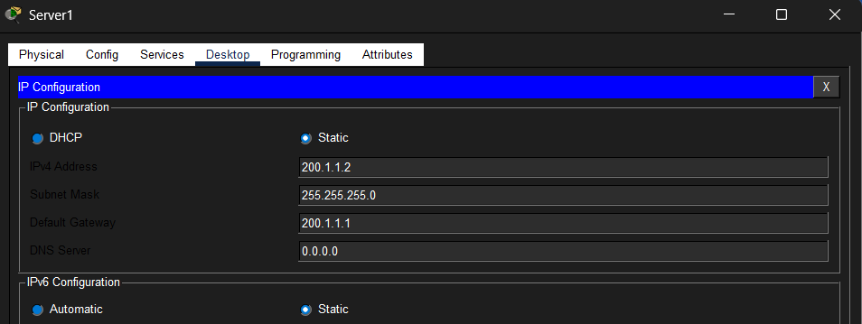

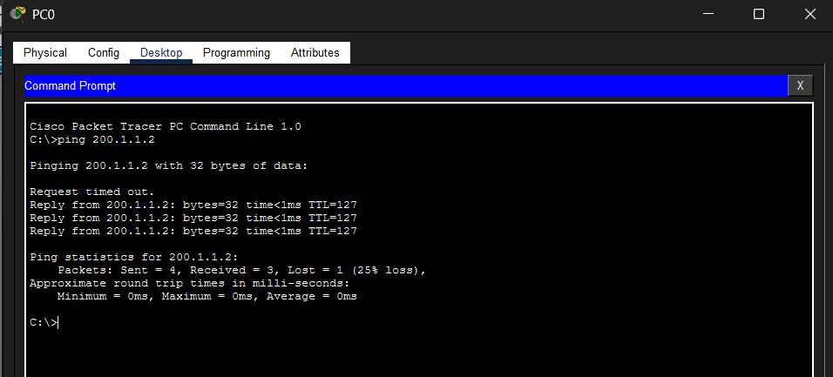
Network Address Translation (NAT) was configured on the router using CLI commands. An access control list was created to permit the private network, and NAT overload was enabled to allow multiple devices to share a single public IP address.

The configuration was tested by sending a ping from the PC to the server using the command prompt. The ping was successful, indicating proper communication between the internal network and the external network.

